Examination, 2017

Question/Answer Booklet

ECONOMICS MOCK EXAMINATION

Student Number: in figures

In words:

Student Name: __________________________________________

Time allowed for this paper

Reading time before commencing work: ten minutes
Working time for paper: three ( 3 ) hours

Materials required/recommended for this paper
To be provided by the candidate
Standard items: pens (blue/black preferred), pencils (including coloured), sharpener,
correction fluid/tape, eraser, ruler, highlighters
Special items: non-programmable calculators approved for use in the WACE examinations

Important note to candidates
No other items may be taken into the examination room. It is your responsibility to ensure that you do not have any unauthorised notes or other items of a non-personal nature in the examination room. If you have any unauthorised material with you, hand it to the supervisor before reading any further.
Structure of this paper

Section | Number of questions available | Number of questions to be answered | Suggested working time (minutes) | Marks available | Percentage of examination
Section One:  Multiple-choice | 24 | 24 | 30 | 24 | 24
Section Two:  Data interpretation / Short response | 3 | 3 | 70 | 36 | 36
Section Three:  Extended response | 4 | 2 | 80 | 40 | 40
 |  |  |  | Total: | 100

Instructions to candidates

1. Answer the questions according to the following instructions.

Section One: Answer all questions on the separate Multiple-choice Answer Sheet provided. For each question shade the box to indicate your answer. Use only a blue or black pen to shade the boxes. If you make a mistake, place a cross through that square, then shade your new answer. Do not erase or use correction fluid/tape. Marks will not be deducted for incorrect answers. No marks will be given if more than one answer is completed for any question.

Section Two and Three: Write answers your answers in this Question/Answer booklet.

2. You must be careful to confine your responses to the specific questions asked and to follow any instructions that are specific to a particular question.

3. Supplementary pages for the use of planning/continuing your answer to a question have been provided at the end of this Question/Answer booklet. If you use these pages to continue an answer, indicate at the original answer where the answer is continued, i.e. give the page number.

Section One: Multiple Choice (24 Marks)

This section has 24 questions. Answer all questions on the separate Multiple-choice Sheet.

For each question shade the box to indicate your answer. Use only a blue or black pen to shade the boxes. If you make a mistake, place a cross through that square, then shade your new answer. Do not erase or use correction fluid/tape. Marks will not be deducted for incorrect answers. No marks will be given if more than one answer is completed for any question.

Suggested working time: 30 minutes.
___________________________________________________________________

- In 2016, Australia’s top two-way trading partners were:
- China, Korea and the USA
- China, Japan and Korea
- China, USA and Japan
- USA, Korea and the EU

- Which of the following is likely to increase Australian exports?
- an increase in income in Australia
- a decrease in income in Australia
- a decrease in income in foreign countries
- an increase in income in foreign countries

- Which of the following is most likely to improve Australia’s International Competitiveness?
- Decreased government spending on infrastructure and education
- A rise in Australia’s inflation rate relative to its trading partners
- A depreciation of the US Dollar against the Australian dollar
- Australia signing more free trade agreements with neighbouring countries

- Restricting imports
- can protect Australian jobs in the protected industry, which increases economic welfare of the country as a whole.
- can protect Australian final goods and services in the protected industry and makes consumers better off.
- can protect Australian final goods and services in the protected industry and increase economic welfare of the country as a whole.
- can protect Australian jobs in the protected industry but will also lead to reductions in Australian output and income.

- Which two of the following arguments are most likely to be used to justify protectionism?
i) To protect high cost domestic industries
ii) To protect strategically important industries
iii) To protect industries which are still immature
iv) To maximise government tax revenue
v) To protect environmental standards

- ii. and iii.
- i. and ii.
- iv. and v.
- iii. and iv.

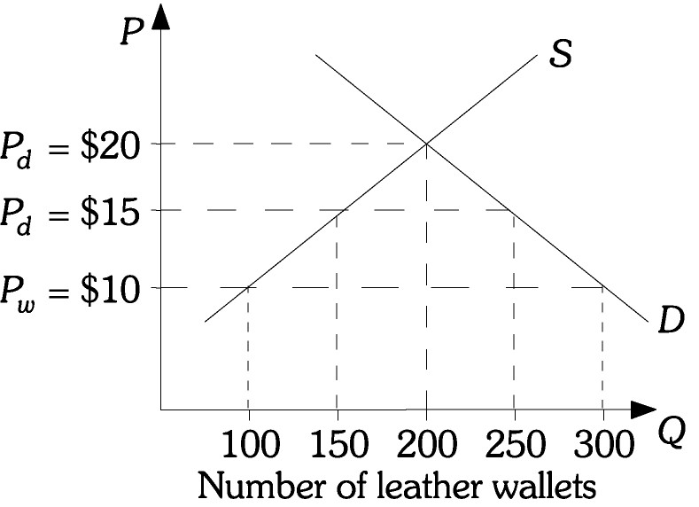
- Refer to the figure opposite. The domestic price of a leather wallet is $20. With free trade the price of a leather wallet is $10 and after a tariff is imposed the price is $15. After the tariff is imposed, tariff revenue will equal
- $50.
- $250.
- $500.
- $750.

- If the Australian dollar appreciates then it is likely that the
- Current account deficit will fall
- Trade balance will fall
- Inflow of foreign investment will rise
- Net income balance will rise

- This question is based on the graph below:

Number of hours to
produce one Computer
AUSTRALIA
12
UK
6
Number of hours
to produce one Car
12
9

According to the graph above which of the following is correct?

- The UK has a comparative advantage in cars
- Australia should export cars and import computers
- The UK should produce both goods
- Australia should import cars and export computers

- Foreign Direct Investment impacts Australia by:
- Increasing taxation revenue for the government
- Creating increased interest payments overseas
- Adding to Australia’s foreign debt levels
- Adding to Australia’s foreign assets

- A currency depreciation is more likely to increase a country's balance of trade if the demand for that country's exports is ________ and the demand for that country's imports is ________.
- elastic; elastic
- inelastic; elastic
- elastic; inelastic
- inelastic; inelastic

- During 2016-17, Australia’s current account deficit fell to its lowest level in over 30 years. This was mainly due to
- A large increase in the income balance.
- A large increase in the trade balance.
- A large fall in the terms of trade which increased exports.
- A large inflow of foreign direct investment.

- More German companies start to invest in Australia. This will lead to a(n)
- decrease in the demand for dollars and an increase in the demand for euros.
- increase in the demand for dollars and an increase in the supply of euros.
- increase in the supply of dollars and a decrease in the demand for euros.
- increase in the demand for dollars and a decrease in the supply of euros.

- Which of the following is most likely to occur during an upswing phase of the business cycle?
- Falling interest rates
- Falling inflation
- Falling structural unemployment
- Falling levels of inventories

- The relationship between real GDP and potential GDP over the business cycle can be best summarised by which of the following statements?
- Real GDP fluctuates around potential GDP
- Real GDP is always equal to potential GDP
- Real GDP cannot be greater than potential GDP
- Real GDP cannot be less than potential GDP

- In a closed economy with no government, the national output increases by $300 billion as a result of an investment increase of $100 billion, than the MPC for this economy is:
- 0.33
- 0.67
- 1
- 3

- A $100 million decrease in government expenditure on goods and services leads to an even larger decrease in aggregate demand because of
- automatic fiscal stabilisers.
- induced changes in consumption expenditures.
- induced changes in aggregate supply.
- induced changes in government taxes.

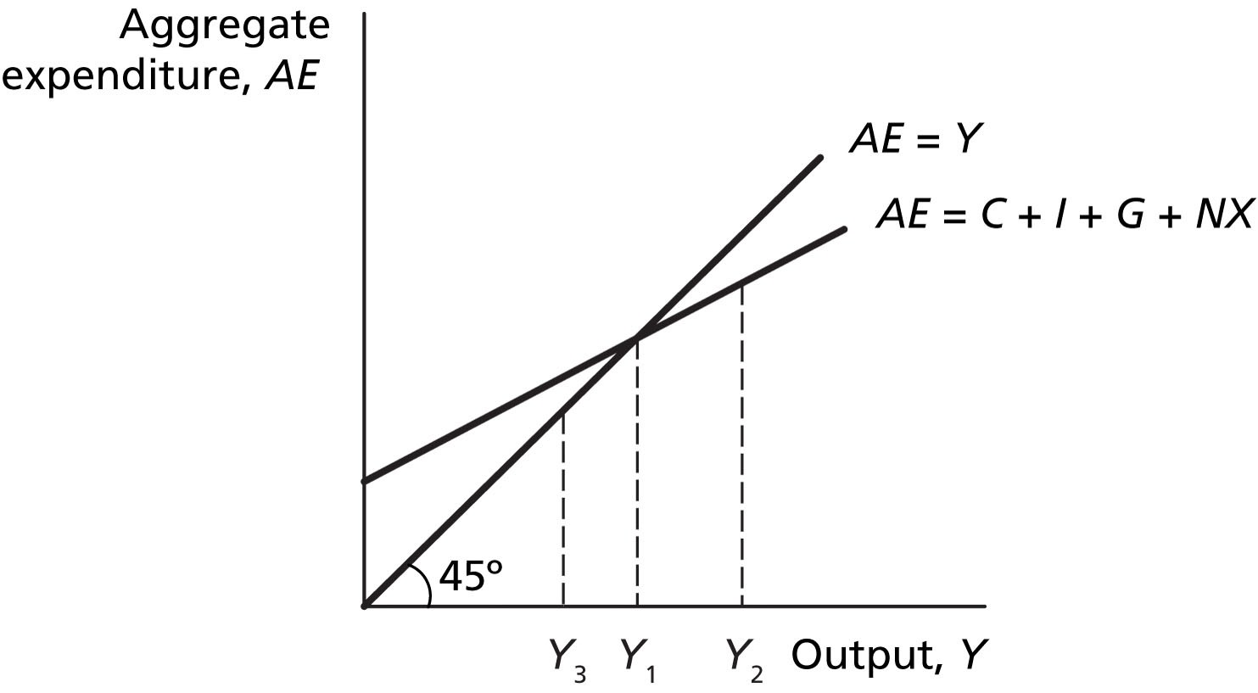
- Refer to the Figure opposite. If the level of real GDP is initially Y3, spending is ________ production and there is an unintended ________ in inventories.
- greater than; decrease
- greater than; increase
- less than; increase
- less than; decrease
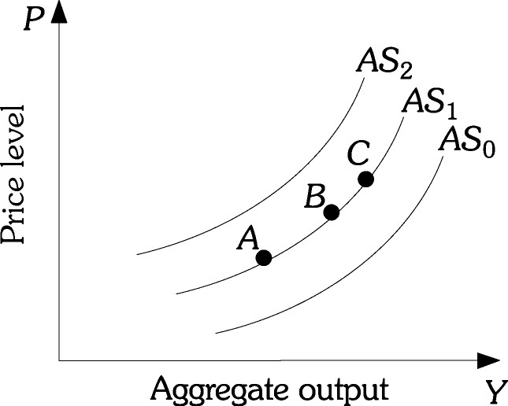
- Refer to the Figure opposite. If a cyclone destroyed a large portion of the infrastructure along the east coast of Australia, this would cause the
- economy to move from Point B to Point C along AS1.
- economy to move from Point B to Point A along AS1.
- aggregate supply curve to shift from AS1 to AS2.
- aggregate supply curve to shift from AS1 to AS0.

- Which one of the following is a weakness of using monetary policy to achieve the Australian Government’s macroeconomic goals?
- Monetary policy requires political approval.
- Indebted households are very sensitive to interest rate changes.
- Banks are not legally required to pass on any changes in the cash rate.
- Monetary policy is relatively inflexible in response to changing economic circumstances.

- The ‘transmission mechanism’ refers to the way a change in interest rates affects economic activity. The transmission occurs via a number of channels. The channel that affects decisions by those in the economy with existing variable rate home loans is known as the
- asset values channel.
- exchange rate channel.
- cost of credit channel.
- cash flow channel.

- A possible cause of a government’s actual budget surplus being smaller than its intended budget surplus could be:
- A rise in the terms of trade
- The RBA lowers interest rates over the period
- A lower level of economic activity than forecast
- Tax receipts have risen during the year

- Australia’s unemployment rate decreased from 5.9% in January 2017 to 5.6% in June 2017. The impact of this change on government tax receipts, government outlays and the size of the budget deficit is likely to be that
- tax receipts increase, outlays increase, the budget deficit is reduced.
- tax receipts increase, outlays decrease, the budget deficit is reduced.
- tax receipts increase, outlays decrease, the budget deficit is increased.
- tax receipts decrease, outlays increase, the budget deficit is increased

- Most economists agree that ___________ are the single most important source of productivity improvements.
- increases in immigration
- increases in physical capital
- discoveries of natural resources
- technological advances

- Which of the following have contributed to structural change in the Australian economy?
i. changes in commodity prices
ii. aging of the population
iii. changes in inflation
iv. monetary policy
v. changes in technology

- i, ii and iii
- ii, iii and iv
- i, ii and v
- All five
__________________________________________________________________

End of Section 1

THIS PAGE HAS BEEN
INTENTIONALLY LEFT BLANK
Section Two: Data interpretation/Short response (36 Marks)
This section contains three (3) questions. Answer all questions. Write your answers in the spaces provided.

Spare pages are included at the end of this booklet. They can be used as additional space if required to continue an answer. If you need to use the space to continue an answer, indicate in the original answer space where the answer is continued, i.e. give the page number. Fill in the number of the question(s) that you are continuing to answer at the top of the page.

Suggested working time: 70 minutes.
__________________________________________________________________

Question 25 (12 marks)

Study the graph and answer the following questions.
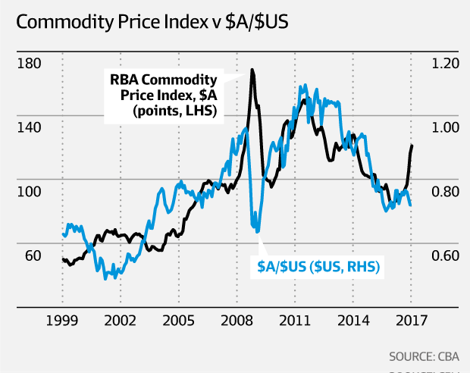

(a) | (i) What is measured by the commodity price index? | ( 1 mark )
 | Index measuring prices received for raw material

 | (ii) Provide a reason for the change in the commodity price index between 2012-2015. |  | ( 2 marks )
Decrease in level of Economic Growth in China led to a fall in D for iron ore
Or Completion of construction phase in iron ore industry led to an increase in S
 | Use the graph to explain the relationship between the commodity price index and the $A. ( 3 marks )
Generally there is a positive relationship
During GFC $fell CPI rose due to perception that Aus eco is dependant on world eco
After 2012 $A fell more slowly than CPI due to positive interest rate differential & Aust being seen as safe haven

(c) | Explain why the $A did not rise given the spike in the commodity price index at the end of 2016. ( 2 marks )
Many thought rise in commodity prices was only temporary and there was worry about Trump protectionism and its impact on Chinese economy growth.
Any other reasonable suggestion

(d) | Describe the change in the value of the $A since 2011 and discuss three effects of this change on the economy. ( 4 marks )
Depreciated which means Xs are cheaper and Ms are dearer.
M competing industries benefit, particularly tourism and education
Economy expanding – UE may fall
Question 26 (12 marks)

Study the statistics which are for an economy similar to Australia’s and answer the questions which follow.

Year | CPI | Change in GDP (%) | CAD (m) | Unemployment rate ($) | Participation rate (%)
1 | 102 | 2 | -8 | 5.8 | 64
2 | 105 | 3 | -13 | 6.2 | 65
3 | 107 | 2 | -14 | 5.9 | 65
4 | 108 | 2 | -3 | 6.0 | 64

(a) | (i) Calculate the inflation rate in year 3. | ( 1 mark )
1.9%
 | (ii) What is the growth rate in year 2? | ( 1 mark )
3%
(b) | Use data from the table to show the position of this economy on the business cycle. | ( 4 marks )
Trough, downswing 1 mark
Should refer to low inflation, flat eco growth, narrowing deficit, rising UE 3 marks

(c) | What policy action should be undertaken in year 4 and what would the impact of such action be on the economy? | ( 6 marks )
Stating and explaining that the action should be expansionary MP and FP (2 marks)
Use AD/AS Model explain impact including increase in AD and resulting increase in eco growth and inflation (possibly) OR
AE model – multiplier effect of increase in govt spending
(2 marks for model and explanation)
Use of examples in fiscal policy – types of spending
May point out that MP not effective in times of low eco growth
2 marks for examples or limitations

Question 27 (12 marks)

Use the article below to answer the questions that follow:

Penalty rate cuts could backfire on business
Analysis
By business reporter: Michael Janda
Thu 23 Feb 2017, 12:14pm
Let's start by calling a spade a spade. Sunday penalty rates have been cut by the Fair Work Commission. Not "equalised" or "brought in line" with Saturday rates. Cut.
Business, big and small, has been seeking this cut for years, saying Sunday penalties are a legacy of a bygone era where families went to church — one that's costing them a tidy sum.
They also argue it's a legacy that's been costing jobs, with many employers choosing not to open on Sundays, or to maintain just a skeleton staff (although ask yourself, just how many retailers, restaurants, cafes and bars are actually shut on Sunday?).
But the cuts to Sunday penalty rates could become a textbook example of unintended consequences, where a move supposed to increase employment instead hurts the economy and increases business failures and job losses.
Why? Because the hundreds of thousands of retail and hospitality workers affected by this decision are also customers.

(a) | Define unintended consequences | ( 1 mark )
An unexpected result or any other equivalent statement

(b) | What economic reasons do employers give for the need to cut penalty rate on Sundays? | ( 2 marks )
Control costs/reduce costs
To reflect current society values
Increase ability to employ people
Any 2 for 1 mark each

(c) | Use AS/AD analysis to explain the economic basis for the cuts. | ( 3 marks )
Use AD/AS model to show a rightward shift in AS
2 marks for diagram plus explanation
1 mark for result

(d) | Use the aggregate expenditure model to describe the possible impacts on the economy. | ( 6 marks )
AE decrease shown on model plus description of negative multiplier effect
4 marks diagram plus explanation
Impacts on economy: decrease in eco activity due to decrease in consumption (2 marks)

Section Three: Extended response (40 Marks)

This section contains four (4) questions. Answer two (2) question.

Pages are included at the end of this booklet for planning and writing your answer.
- Planning: If you use the spare pages for planning, indicate this clearly at the top of the page.
- Answering the question: In the pages provided indicate clearly the number of the question you are answering.
Suggested working time: 80 minutes.
___________________________________________________________________

Question 28

(a) | Describe factors that could improve Australia’s international competitiveness.
 | ( 10 marks )

(b) | Analyse the impact of a fall in the exchange rate on different sectors of the Australian economy. ( 10 marks )
Question 29

(a) | Explain why international trade and direct foreign investment are important to the Australian economy. ( 10 marks )

(b) | Discuss the effect an increase in protectionism worldwide would have on the Australian economy. ( 10 marks )

Question 30

There has been a lot of speculation about the possibility of the RBA raising the cash rate in the last few years.

(a) | What economic conditions would need to exist for the RBA to increase the cash rate and explain what impact this change would have on the Australian economy. ( 10 marks )

(b) | Using contemporary examples, describe the strengths and weaknesses of Monetary Policy. ( 10 marks )
Question 31

(a) | Explain the extent to which Australia’s recent fiscal policy measures are enabling the achievement of Australia’s economic objectives. ( 20 marks )
___________________________________________________________________
End of Questions

End of Exam

